MEMO

To: WV STARS PD Provider

From: WV STARS

Date: 9/18/20

Re: Changes to Webinar Hyperlink Feature and Date/Time of Scheduled Events

Dear WV STARS PD Providers,

Hello everyone! There are two new items I want to address:

1. As of September 17th 2020, a new addition known as the Webinar Hyperlink feature will be available for use with Scheduled Events.

This feature was developed to address some of the challenges of clients navigating the transition from face-to-face to virtual learning due to Covid 19. This feature allows admins to add a web link for a webinar into a designated field in Scheduled Event Management. This powerful feature will allow for the use of a wide range of online live training without requiring integration with one specific online meeting software. Upon release this feature will be immediately available to any admin that has the 'Scheduled Events: Create & Edit Schedules' permission.

The admin will see a new ability to enter a Webinar Link and a Webinar Link Label (the label is optional).





In addition, the admin can choose whether the link displays to a user prior to or only after registration. The default setting is set to only after registration.



The link is visible to the admin in Scheduled Event Management and to the user in the same locations that the location is typically visible based on the settings above.

The Scheduled Event Registration email will contain a clickable hyperlink as shown below:

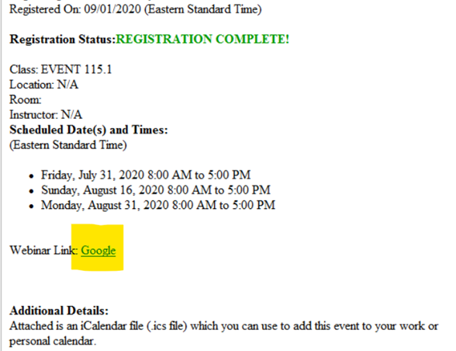

Please note that there is a 200-character limit on the Webinar Hyperlink Label at this time.

1. In the date/time section of your scheduled event, adding the date/time is now done by inputting the data in the “When” boxes instead of clicking directly on the Calendar. You can also click on the Calendar icon or the clock icon to select a date or time respectively.

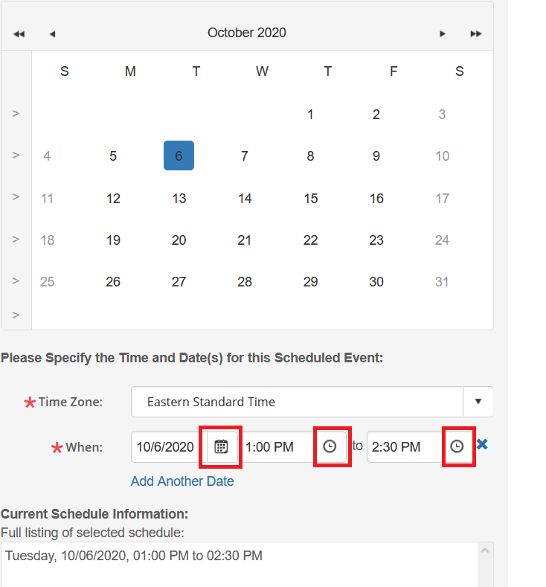

You can add multiple dates by clicking “Add Another Date”. All dates currently scheduled will show up in the “Currently Scheduled Information “box. To delete a date, simply click the blue box next to the date you want deleted.

If the instructor selected is available during the chosen time frame, the box around the date on the calendar will turn blue (as seen above). If not, it will be red and dictate it is unavailable: 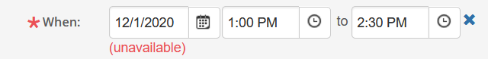

Please remember to input the correct time with every scheduled event to avoid any system scheduling conflicts.

If you have any questions please contact me.